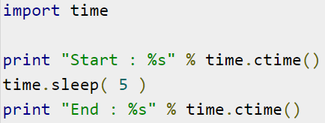

* Write a program to control the temperature of a fish tank
* Monitor the temperature
* When the temp drops below 24 deg C apply heat
* When the temp is above 27 deg C stop applying heat
* Simulate the temperature. Temperature will drop 1 deg every 5 seconds